Booting VMware 3i off of a Hard Drive
Version 2.1
Written by : Scott Surovich vmware@disneyhq.com
History
Like many, after getting back from VMworld 2007 I was very excited to use my new 3i beta memory stick. After a nice weekend in San Francisco I went to work on Monday, went to my lab at work and attempted to boot my 3i off of my Compaq DL380 G2. Of course I quickly discovered that the G2’s do not boot off of a memory stick. I have a ton of these around and I really wanted to use them for 3i testing – but what could I do?
Not one to back away from a challenge, I decided to attempt to figure out how to get the image from my USB memory stick to a hard drive on my server.
After a few hours of playing around I managed to get an image to a single 18GB drive (you could use more, but why would you for a 1GB memory stick image?). I managed to get the disk to boot but at 85% or so the boot sequence stopped and if you look at the boot screen it says it cannot find a USB boot partition. I thought I was done….. BUT then I decided to boot again with the USB stick in the server and SUCCESS! I now have 3i running via hard drives on a DL380 G2, and I can now get it to boot on any server regardless to if it is able to boot from memory stick or not.
As of Version 2 of this doc, you no longer need the USB stick on the server to boot.
So, how do you accomplish this?
What’s needed?
- A Server (Mine was a DL380 G2 with a 5300 array controller)
- winscp (http://winscp.net/)
- knoppix boot CD (http://www.knoppix.org/)
- dd for windows (http://www.chrysocome.net/downloads/dd-0.5.zip)
- your 3i USB stick from VMworld (Please do not email me for this image - I will ignore all email requesting any 3i images)
- You will also need around 1GB of ramdrive space on your knoppix ramdrive (as long as your server has more than 1.5GB of ram you’ll be fine)
- Once installed you will need to modify a single boot file
Step by Step – Imaging your memory stick (on Windows)
Make an image of your 3i memory stick using the DD program from above. The command you will likely need to issue is: (If this does not work please read an excellent doc that was on the VMworld 2007 site – I can’t find the link now but I plan to add the author to this doc for that find)
dd of=VMware-VMvisor-big-e.x.p-XXXXX.i386.dd if=\\?\Device\Harddisk1\Partition0 bs=1M --size --progress
You should now have a .dd file that is an exact image of your 3i memory stick, this is the image we will use on the server.
Step by Step – Boot from your Knoppix CD
Insert your Knoppix CD into your server and boot from it. Depending on the server you may need to issue a Knoppix boot parameter or you may crash while booting the CD. On the 380 G2 I had to issue:
knoppix acpi=off noapic pci=bios
Wait for Knoppix to load and then get to a console mode. Once in console mode issue an su for root access (the password should be blank).
Step by Step – Get your .dd image to the Server
There are multiple ways to get the image to the Knoppix server, this one covers SCPing it over, but I have also used a USB drive and just imaged it straight from that).
By default SSH is off on your Knoppix server, so let’s turn it on:
/etc/init.d/ssh start
I had issues using winscp with root and blank password, so on your server change your root password to something other than blank, maybe password so it’s easy to remember:
passwd root
It will prompt for the password twice – if it was changed successfully it will tell it has updated the credentials successfully.
We now need the IP address of your Knoppix server so issue:
ifconfig
Write down the IP – If you have no IP, that will require troubleshooting that beyond the scope of this document.
Run winscp from your Windows machine and connect to your Knoppix server (See Figure 1)
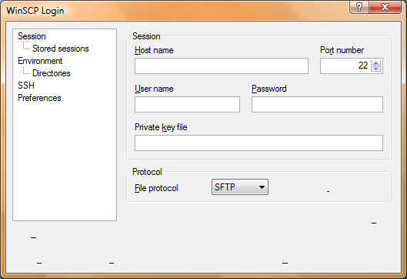
Figure 1
Enter your server IP address, use the username root, and the password you created on the previous page. When you press enter it will pause for a few seconds and prompt you to accept the key – accept it. Once connected you will see figure 2.
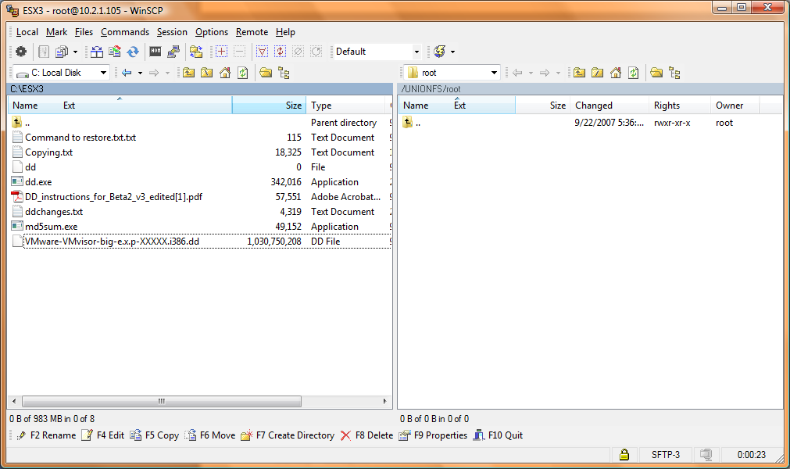
Figure 2
Select the .dd file from the right side and drag it over to the left (this is roots home folder on Knoppix).
Depending on your speed the copy will take 2-5 minutes (wireless could be 30 minutes or more).
Once the copy is complete you will no longer need your Windows machine.
On your Knoppix server change directory to root’s home folder:
cd /root
Now this part MAY change depending on the server you are using. You will need to know the device of your destination hard drive. In my case, since it’s a DL380 G2 my destination is /dev/cciss/c0d0. I only have access to Compaq/HP servers, but if you have issues finding this I will try to assist in any way I can.
Using dd we will now transfer the image to our hard drive(s):
dd if=VMware-VMvisor-big-e.x.p-XXXXX.i386.dd of=/dev/cciss/c0d0
This will take a few minutes, but during the image process you will see nothing – just wait until your prompt comes back.
Congratulations! You now have an image on your hard drive.
Step by Step – Lets boot our new 3i Server
Either power down your Knoppix server or shutdown via the Knoppix GUI – either way, on next boot make sure your CD is not in the drive.
Power your server up and it will boot off of your HD – at the main 3i boot screen press SHIFT and O (That’s a capital letter o, not a zero), this will let you pass a boot parameter to 3i. At this parameter type:
nousbboot shell
This will boot the 3i server off the HD completely, and the shell parameter will allow us to modify the 3i boot file to pass the nousbboot to the bootup file.
Once your 3i server has booted press ALT and F1 to gain a prompt. (username is root and password is <blank> - unless you have set one) This find is thanks to http://scalethemind.blogspot.com/
Now, edit the file boot.cfg located at /bootbank with:
vi /bootbank/boot.cfg
Modify the line for kernel options, the line currently reads kernelopt= (Move to the end and press the letter i for insert)
kernelopt=nousbboot shell
Now press the <ESC> key and type :wq
(For write and quit).
You’re all done, REBOOT and it will no longer need the USB stick – and you will not need to supply the nousbboot, it will be passed automatically.
Final Thoughts
Thanks for reading – This document was written quickly so I could get it out and I apologize for any grammar and spelling errors. My RIB is having issues at this time so I will add more detailed pictures to assist people in Version 2 of this doc.

